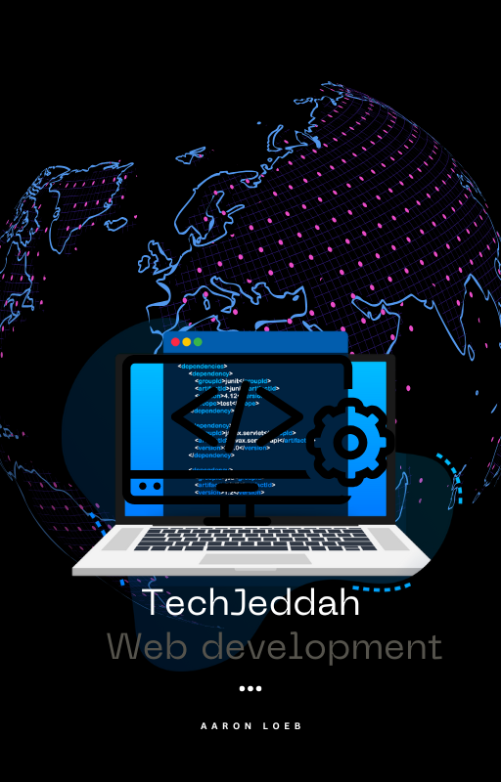

**Full Stack Development - Beginner Friendly Summary**

**🔰 Phase 1: Building the Basics (Week 1–11)**

**Learn the Core of Web Development**

* **HTML & CSS**: Build web pages using Tailwind CSS
* **JavaScript**: Understand functions, loops, arrays, and objects
* **DOM & Events**: Make your website interactive
* **Projects**: Responsive business website, quiz, form validation, weather app

**⚛️ Phase 2: Frontend with React (Week 12–16)**

**Create Dynamic Websites**

* **React Basics**: Components, props, state
* **Routing & Hooks**: Use React Router, useState, useEffect
* **APIs & Auth**: Work with data and protect routes
* **Projects**: Task app, blog site, shopping cart, full React app

**🛠️ Phase 3: Backend with Node.js (Week 17–20)**

**Build Server-Side Apps**

* **Node.js & Express**: Set up a backend server
* **MongoDB**: Store and manage data
* **Authentication**: User login with JWT
* **Projects**: Product API, user auth system, file upload app

**🔗 Phase 4: Full-Stack Projects (Week 21–24)**

**Combine Frontend + Backend**

* **MERN Stack**: React + Node + MongoDB
* **Integrations**: Forms, state management, real-time features
* **Final Project**: Create a full e-commerce app or job portal

**💡 Learning Style**

* 💻 **Hands-On Projects**
* 🎓 **Live Coding & Group Discussions**
* ✅ **Weekly Quizzes & Final Capstone Project**

**🧰 Tools You’ll Use**

* **Frontend**: HTML, CSS, Tailwind, JavaScript, React
* **Backend**: Node.js, Express, MongoDB
* **Deployment**: Vercel, Netlify, AWS
* **Version Control**: Git & GitHub